Harworth Church of England ACADEMY
Friday 22nd April 2022

Welcome Back and Reading Wristbands

Welcome back to our lovely summer term. It has been so great to see everyone this week.

We are launching our reading wristbands this week. They will be given for children who have perfected their reading and performance of poetry. They will take a lot of earning, but the children are up for the challenge!

We look forward to seeing you for a coffee on Thursday morning if you can make it.

Thank you for your continued support,

Kerrie

Attendance for the week beginning
Tuesday 19th April
• EYFS 94%
• Elf Owls 97%
• Snowy Owls 92%
• Barn Owls 99%
• Tawny Owls 98%
• Eagle Owls 97%
• Wise Owls 95%
KINDNESS
Our Christian Value this term is Kindness. Kindness pins are given out on Fridays for extreme acts of kindness. The children have been rehearsing our anti-bullying slogan of NO GO TELL, which is a zero tolerance message for bullying. The children are using NO GO TELL for any behaviour that makes them feel at all upset. Our aim is to BE KIND at all times.

Clubs - Clubs are starting back next week. You should have received letter from each club for you to sign. This is a list of them all:
Tuesday – Singing for Key Stage 1 and Year 3
Colouring for EYFS
Wednesday – Football for Key Stage 2
Reading Club for Years 4,5,6
Reading Club for Years 2 and 3
Thursday – Chess for Key Stage 2
Tennis for Key Stage 1
Friday – Singing for Years 4,5,6

School photographs – Tuesday 26th April.
Next Coffee morning is Thursday 28th April.

Bank holiday Monday is Monday 2nd May. We break for May half term on Friday 27th May. We return to school on Monday 6th June. We break for the summer on Friday 22nd July. We return after the summer break on Monday 5th September, as Thursday 1st and Friday 2nd September are INSET days.
Please find attached our booklet of ‘things to do that give me wings.’ The children have a copy of this in school.
Things to do that give me wings
at Harworth Church of England Academy
Motivated by our pledge to Amaze, Achieve, Aspire
at Harworth Church of England Academy we have
listed 40 things that all children should experience.
Combined with our love of fun and a carefully mapped
out curriculum all of these things will be completed by
the end of Primary School, some of them many, many times over.
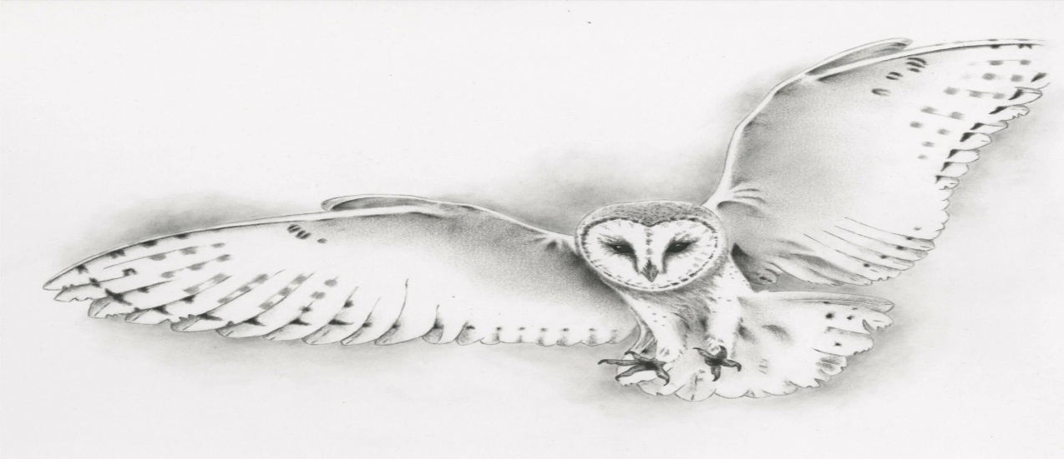

Have an indoor picnic
Read a book outdoors
Learn about the Pilgrim Fathers
Learn about coal mining
Go down a coal mine
Know 20 capital cities
Recognise 20 flags of the world
Learn and recite your favourite poem
Keep a journal
Build a den
Dance in the rain
Dance like no one is watching
Blow bubbles
Take notice of birds and find out what they are
Learn to play chess
Learn First Aid
Learn to play an instrument
Skip as often as you can
Collect something
Plant and grow some seeds
Bake a cake and eat it
Zentangle
Visit a museum
Visit an aquarium
Undertake an enterprise project
Visit and learn about Church
Follow the Moon for a month
Learn to sew
Watch a live performance
Take part in a debate
Make a list of your favourite words
Learn another language
Try new fruits and vegetables
Make up a game
Watch clouds
Swim a length
Be happy
Look for the good in everything
Always be kind
Amaze Achieve Aspire

